Week 6:

--Practice Session- Coding

ROLL NO.:240801178

Name: Logesh.M

Q1) Given an array A of sorted integers and another non negative integer k, find if there

exists 2 indices i and j such that A[i] - A[j] = k, i != j.

Input Format

1. First line is number of test cases T. Following T lines contain:

2. N, followed by N integers of the array

3. The non-negative integer k

Output format

Print 1 if such a pair exists and 0 if it doesn’t.

Sample Input:

1

3 1 3 5

4

Sample Output:

1

Code:

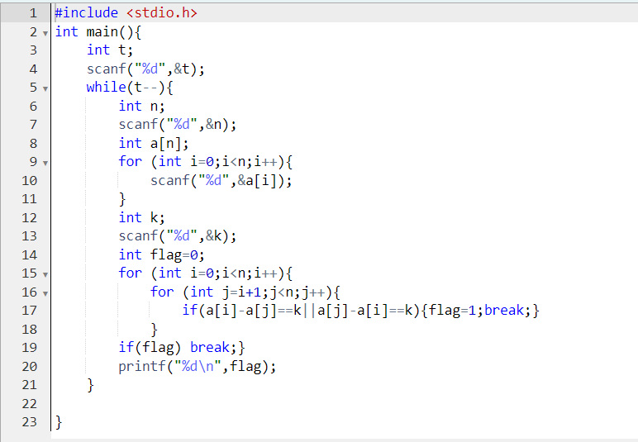

Output:

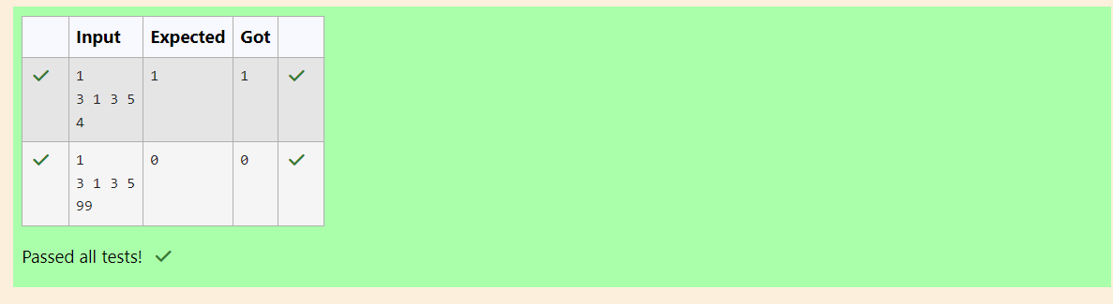

Q2) Sam loves chocolates and starts buying them on the 1st day of the year. Each day of the

year, x, is numbered from 1 to Y. On days when x is odd, Sam will buy x chocolates; on

days when x is even, Sam will not purchase any chocolates.

Complete the code in the editor so that for each day Ni (where 1 ≤ x ≤ N ≤ Y) in array

arr, the number of chocolates Sam purchased (during days 1 through N) is printed on a

new line. This is a function-only challenge, so input is handled for you by the locked stub

code in the editor.

Input Format

The program takes an array of integers as a parameter.

The locked code in the editor handles reading the following input from stdin, assembling

it into an array of integers (arr), and calling calculate(arr).

The first line of input contains an integer, T (the number of test cases). Each line i of

the T subsequent lines describes the ith test case as an integer, Ni (the number of days).

Constraints

1 ≤ T ≤ 2 × 105

1 ≤ N ≤ 2 × 106

1 ≤ x ≤ N ≤ Y

Output Format

For each test case, Ti in arr, your calculate method should print the total number of

chocolates Sam purchased by day Ni on a new line.

Sample Input 0

3

1

2

3

Sample Output 0

1

1

4

Code:

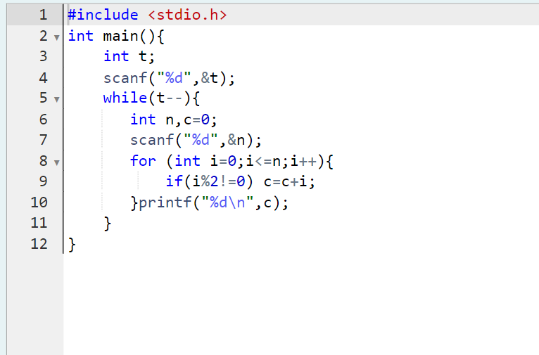

Output:

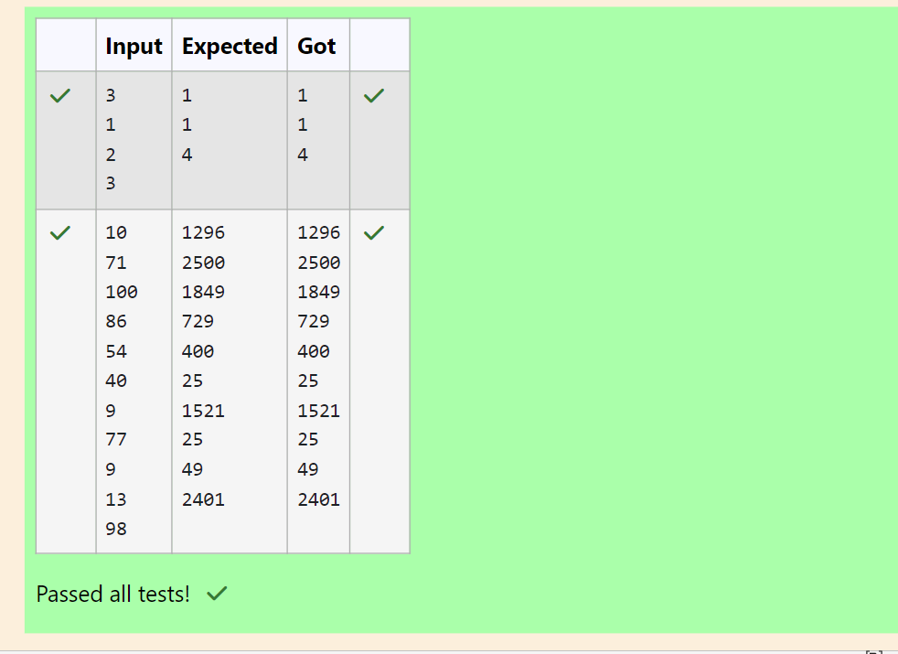

Q3) The number of goals achieved by two football teams in matches in a league is given in the

form of two lists. Consider:

• Football team A, has played three matches, and has scored { 1 , 2 , 3 } goals in each match

respectively.

• Football team B, has played two matches, and has scored { 2, 4 } goals in each match

respectively.

• Your task is to compute, for each match of team B, the total number of matches of team A,

• where team A has scored less than or equal to the number of goals scored by team B in

that match.

In the above case:

• For 2 goals scored by team B in its first match, team A has 2 matches with scores 1 and 2.

• For 4 goals scored by team B in its second match, team A has 3 matches with scores 1, 2

and 3. Hence, the answer: {2, 3}.

Complete the code in the editor below. The program must return an array of m positive

integers, one for each maxes[i] representing the total number of elements nums[j]

satisfying nums[j] ≤ maxes[i] where 0 ≤ j < n and 0 ≤ i < m, in the given order.

It has the following:

nums[nums[0],...nums[n-1]]: first array of positive integers

maxes[maxes[0],...maxes[n-1]]: second array of positive integers

Constraints:

2 ≤ n, m ≤ 105, 1 ≤ nums[j] ≤ 109, where 0 ≤ j < n, 1 ≤ maxes[i] ≤ 109, where 0 ≤ i < m.

Input Format For Custom Testing

Input from stdin will be processed as follows and passed to the function.

The first line contains an integer n, the number of elements in nums.

The next n lines each contain an integer describing nums[j] where 0 ≤ j < n.

The next line contains an integer m, the number of elements in maxes.

The next m lines each contain an integer describing maxes[i] where 0 ≤ i < m.

Sample Input

4

1

4

2

4

2

3

5

Sample Output

2

4

Code:

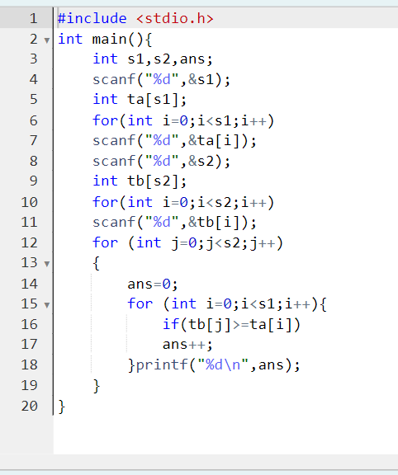

Output:

